Salzburg Festival 2019

CONTENT

Preface by the Directorate of the Salzburg Festival ………………………………. p. 2

The 2019 Salzburg Festival: Fact and Figures …………………………………….. p. 3

Press Text: The 2019 Salzburg Festival Programme ………………………..……. p. 4

Opera …………………………………………………………………………………… p. 4

Drama ……………………………………………………………………………….….. p. 9

Concerts ……………………………………………………………………………….. p. 13

Children’s and Youth Programme ………………………………………………….. p. 17

Sponsors ………………………………………………………………………………. p. 20

Budget, Tickets, Value Creation, Service …………………………………………. p. 24

Joseph Beuys ………………………………………………..……………………….. p. 25

Photos …………………………………………………………………………………. p. 26

The Salzburg Festival presents its programme in the following cities: Salzburg, Vienna, Paris, Munich, Zurich, London, New York, Beijing, Seoul, Berlin, Hamburg and Moscow.

Press Office of the Salzburg Festival | +43-662-8045-351 | presse@salzburgfestival.at

PREFACE by the Salzburg Festival’s Directorate

In 2019, we hope to kindle your empathy for myths from antiquity, which the Festival co­founder Hugo von Hofmannsthal saw as a “magic mirror”. Mythical tales from long ago still raise ever­relevant questions about human existence, addressing themes of war, flight, sacrifice, revenge, guilt and atonement.
The opening premiere will be Mozart’s Idomeneo. Here, the ruler – torn between duty to the gods and love for his family – is forced to deliberate and take action. This contrasts with the awareness lacked by the title character of George Enescu’s opera Œdipe: he becomes guilty without fault. Family conflicts and political disputes also appear in the gripping plot of Verdi’s Simon Boccanegra, a work which recalls the fateful intricacies familiar to us from the great mythic tales of humanity’s ancient past.
One of the key female figures in mythology is Medea, who features twice in our programme. Luigi Cherubini’s 1797 opera Médée, which he based on Euripides’ tragedy, is an extraordinary drama of the soul, driven by disappointed love and bloody revenge. An unsettling contemporary version is then offered by the French composer Pascal Dusapin in his operatic adaptation of Heiner Müller’s Medeamaterial. Jacques Offenbach reacted in a very different way to his era’s cult of myth: his operetta Orphée aux enfers is both a parody and a social satire.
And as is now tradition every year, we will showcase the Whitsun opera with our wonderful Cecilia Bartoli once more in the summer. George Frideric Handel’s Alcina is deeply rooted in the rich traditions of oral storytelling of bygone times.
The drama programme will also engage with myths. The world premiere of Theresia Walser’s Die Empörten (The Outraged Ones) transposes the elemental conflict between Antigone and Creon to a contemporary setting. Maxim Gorky’s Summerfolk, on the other hand, can be read as an antithesis to mythological narrative — here, people hold the responsibility for their own fate. Conversely, the constant divesting of responsibility is thrust into the spotlight with the title character of Ferenc Molnár’s Liliom. There is no escape from the curse that seems to rest on the pupils and teachers in Jugend ohne Gott (Youth Without God), with two members of the group ultimately unable to evade death. Albert Ostermaier tackles the myth of Sisyphus in a dramatic monologue — another world premiere for the Salzburg Festival in an unusual location. Finally, a marathon reading of James Joyce’s Ulysses ties the drama programme directly to Homer’s Odyssey, heard as an echo of antiquity in our time.
Epics from antiquity form a striking proof of the extent to which stories and narrative were also songs. In this year’s Ouverture spirituelle, pain, grief and tears take on musical form. They move our souls and stir up emotions: whether in Orlando di Lasso’s Lagrime di San Pietro, in works by Palestrina, Gesualdo and Bach, in the music of Shostakovich, or in the writing of Nono, Gubaidulina and Rihm.
Hermann Bahr, a guiding intellectual force behind the founding concept of the Salzburg Festival, answered the question of ‘why myths in this day and age?’ with the remark: “My gaze yearns impatiently for the future but prefers to return to times that are long past; this is where I find the future.” – With this in mind, we invite you to join us in the summer of 2019.

Helga Rabl-Stadler Markus Hinterhäuser Lukas Crepaz
The 2019 Salzburg Festival

199 Performances in 43 Days at 16 Venues

Opera: 42 Performances
5 New Productions
2 Operas in Concert
2 Revivals

Drama: 55 Performances
4 New Productions
Revival of Jedermann
4 Drama Investigations
4 Readings

81 Concerts
Staged Performance (Orlando di Lasso: Lagrime di San Pietro / Peter Sellars)
Opera in Concert (Pascal Dusapin: Medeamaterial)
70 Concerts
4 Master Classes
5 Special Concerts

Gala Soiree

20 Performances as part of the Children’s Programme
8 Performances of the Children’s Opera Der Gesang der Zauberinsel
8 Introductory Workshops Fun and Games
4 Public Final Performances of the Opera Camps

***

Joyful Joyce – An Installation by Ruth Beckermann

Photography Exhibition Pascal Dusapin

6 Film Screenings Medea (Pier Paolo Pasolini, with Maria Callas, 1969)

OPERA

Wolfgang Amadeus Mozart Idomeneo
Luigi Cherubini Médée
George Enescu Œdipe
Jacques Offenbach Orphée aux enfers
Giuseppe Verdi Simon Boccanegra

George Frideric Handel Alcina
Richard Strauss Salome

Francesco Cilea Adriana Lecouvreur (in concert)
Giuseppe Verdi Luisa Miller (in concert)

Wolfgang Amadeus Mozart: Idomeneo

The opening premiere of the 2019 Salzburg Festival is Wolfgang A. Mozart’s opera Idomeneo. In 2017 Teodor Currentzis and Peter Sellars staged Mozart’s late opera La clemenza di Tito at the Salzburg Festival as a touching vision of the power of justice and reconciliation. Now the ingenious duo dedicates itself to another opera seria by Mozart during the upcoming Festival summer, the utopian work of a 25-year-old telling the world: “We must talk about the future. The time is ripe for a serious change.“ (Peter Sellars)

The premiere of Idomeneo takes place on July 27 at the Felsenreitschule. Teodor Currentzis conducts the Freiburg Baroque Orchestra and the musicAeterna Choir of Perm Opera. Russell Thomas (Idomeneo), Paula Murrihy (Idamante), Ying Fang (Ilia), Nicole Chevalier (Elettra) and Jonathan Lemalu (Nettuno / La voce) take the principal roles. The Samoan-born artist Lemi Ponifasio, whose career spans the world, will be responsible for the choreography.

Luigi Cherubini: Médée

In Luigi Cherubini’s opera Médée of 1797, Medea is portrayed as a passionate, strong, intelligent woman with the ability to love. Simon Stone, whose production of Aribert Reimann’s Lear provided a highlight of the 2017 Salzburg Festival, explores the reasons for Medea’s actions in a modern context, tracing the figure’s inner development from the beginning to the final catastrophe.

The new production has its premiere at the Großes Festspielhaus on 30 July. Thomas Hengelbrock conducts the Vienna Philharmonic and the Concert Association of the Vienna State Opera Chorus. Sonya Yoncheva, the celebrated Poppea in Monteverdi’s L’incoronazione di Poppea at the 2018 Festival, takes on the title role. She is joined by Pavel Černoch (Jason), Vitalij Kowaljow (Créon), Rosa Feola (Dircé) and Alisa Kolosova (Néris).

George Enescu: Œdipe

It was a scream which George Enescu could not forget: the scream of Oedipus as he was blinded in a performance of Sophocles’ tragedy at the Comédie-Française in 1909. Shortly thereafter, in 1910, he began to sketch the music for an opera. However, it was only 26 years later, on 13 March 1936, that Œdipe, his tragédie lyrique, was first performed in Paris – proving itself a masterwork of 20th-century opera literature.

Achim Freyer is responsible for directing the new production at the Felsenreitschule, as well as its sets and costumes. Ingo Metzmacher conducts the Vienna Philharmonic, the Concert Association of the Vienna State Opera Chorus and the Salzburger Festspiele und Theater Kinderchor. The role of Œdipe is sung by Christopher Maltman. Further roles feature John Tomlinson (Tirésias), Brian Mulligan (Créon), Vincent Ordonneau (Le Berger), David Steffens (Le Grand Prêtre), Gordon Bintner (Phorbas), Tilmann Rönnebeck (Le Veilleur), Boris Pinkhasovich (Thésée), Michael Colvin (Laïos), Anaïk Morel (Jocaste), Clémentine Margaine (La Sphinge), Chiara Skerath (Antigone) and Anna Maria Dur (Mérope). The premiere takes place on 11 August 2019.

Jacques Offenbach: Orphée aux enfers (Orpheus in the Underworld)

Accustomed to success, shortly before his 40th birthday Jacques Offenbach had run into financial turbulence with his theatre near the Champs-Élysées in 1858. His revision and setting of a libretto about Orpheus by Ludovic Halévy and Hector Crémieux brought the much-needed coup: with Orphée aux enfers, he created the prototype of the “Offenbachiade” – and saved his theatre from ruin. The version Barrie Kosky has created for Salzburg essentially keeps to the form of the two­act opéra-bouffon of 1858, with the addition of some elements from the 1874 version which Offenbach had inserted in reaction to the change in social circumstances.

Barrie Kosky makes his Salzburg Festival debut with Orphée aux enfers, as does the conductor Enrique Mazzola. In addition to the Vocalconsort Berlin and the Vienna Philharmonic, Kathryn Lewek sings the role of Eurydice and Joel Prieto that of Orphée. The cast also includes Marcel Beekman (Aristée), Martin Winkler (Jupiter), Max Hopp (John Styx), Anne Sofie von Otter (L’Opinion publique), Peter Renz (Mercure), Vasilisa Berzhanskaya (Diane), Frances Pappas (Junon), Lea Desandre (Vénus) and Nadine Weissmann (Cupidon). The new production at the Haus für Mozart premieres on 14 August.

Giuseppe Verdi: Simon Boccanegra

Simon Boccanegra may be Giuseppe Verdi’s most personal work; it is certainly his darkest and most pessimistic one, in which familiar and political conflicts keep clashing: “The human heart is a fount of never-ending woe”.

Andreas Kriegenburg, who garnered rave reviews with his production of Shostakovich’s Lady Macbeth of the Mtsensk District in 2017, directs Giuseppe Verdi’s opera at the Großes Festspielhaus. Valery Gergiev returns to the Salzburg Festival as an opera conductor, leading the Concert Association of the Vienna State Opera Chorus and the Vienna Philharmonic. Luca Salsi sings the role of Simon Boccanegra, Marina Rebeka that of Amelia Grimaldi and René Pape that of Jacopo Fiesco. The cast also includes Charles Castronovo (Gabriele Adorno), André Heyboer (Paolo Albiani) and Antonio Di Matteo (Pietro). The premiere takes place on 15 August.

George Frideric Handel: Alcina

Directed by Damiano Michieletto and featuring Cecilia Bartoli in the main role, George Frideric Handel’s Alcina is a revival from the Salzburg Whitsun Festival and premieres at the Haus für Mozart on 8 August.

Gianluca Capuano conducts Les Musiciens du Prince – Monaco and the Salzburg Bach Choir. Cecilia Bartoli is joined on stage by Sandrine Piau as Morgana, Kristina Hammarström as Bradamante, Christoph Strehl in the role of Oronte and Alastair Miles as Melisso. Philippe Jaroussky sings the role of Ruggiero, which Handel tailored to the voice of castrato Giovanni Carestini in 1735.

Richard Strauss: Salome

Audience and media agreed that the 2018 production of Richard Strauss’ Salome would go down in Festival history as an overwhelming experience. In 2019 we offer three further performances of the production by Romeo Castellucci (director, sets, costumes and lighting). The cast is the same as last season: the incomparable Asmik Grigorian is joined by John Daszak (Herodes), Anna Maria Chiuri (Herodias), Gábor Bretz (Jochanaan) and Julian Prégardien (Narraboth), among others. The Vienna Philharmonic performs under the baton of Franz Welser-Möst. The premiere is scheduled for 25 August at the Felsenreitschule.

Operas in Concert

Francesco Cilea: Adriana Lecouvreur

Francesco Cilea’s opera Adriana Lecouvreur is performed in concert three times with Anna Netrebko in the title role at the Großes Festspielhaus. Yusif Eyvazov sings the role of Maurizio, Count of Saxony; Anita Rachvelishvili embodies Adriana Lecouvreur’s adversary, the Princess de Bouillon. The cast also includes Nicola Alaimo (Michonnet), Mika Kares (Prince de Bouillon) and Andrea Giovannini (Abbot of Chazeuil). Marco Armiliato conducts the Mozarteum Orchestra Salzburg and the Philharmonia Chorus Vienna. The performances take place on 28 and 31 July and on 3 August.

Giuseppe Verdi: Luisa Miller

Giuseppe Verdi’s opera Luisa Miller, based on Schiller’s Kabale und Liebe, will be heard in two concert performances on 25 and 31 August at the Großes Festspielhaus: Plácido Domingo sings the role of Miller; Piotr Beczala is heard as Rodolfo and Nino Machaidze as Luisa; together they face the merciless severity of Conte di Walter, sung by Roberto Tagliavini. The cast also includes Teresa Iervolino (Federica) and John Relyea (Wurm). James Conlon makes his Festival debut, conducting the Concert Association of the Vienna State Opera Chorus and the Mozarteum Orchestra Salzburg.

DRAMA

One world premiere, three further new productions, the revival of Jedermann, four drama investigations, four readings – including another world premiere – and an installation: all these are included in the 2019 programme of the Festival’s drama department.

Hugo von Hofmannsthal Jedermann
Ödön von Horváth Jugend ohne Gott (Youth Without God)
Maxim Gorky Summerfolk
Ferenc Molnár Liliom
Theresia Walser Die Empörten (The Outraged Ones)

Drama Investigations
Readings · Installation

Hugo von Hofmannsthal: Jedermann

The revival of Hugo von Hofmannsthal’s Jedermann will be performed 14 times during the 2019 Salzburg Festival, starting on 20 July. The production by Michael Sturminger and his team has the following new cast members: Valery Tscheplanowa – who caused a stir last summer in Ulrich Rasche’s production of The Persians – plays the Paramour opposite Tobias Moretti. Gregor Bloéb takes on the double role of Jedermann’s Companion and the Devil. Other debuts on Cathedral Square include Falk Rockstroh as Faith, Helmut Mooshammer as Poor Neighbour, Michael Masula in the role of the Debtor and Markus Kofler as the Cook. Björn Meyer and Tino Hillebrand play the Fat Cousin and the Thin Cousin.

Ödön von Horváth: Jugend ohne Gott (Youth Without God)

A panorama of ruthlessness and coldness in totalitarian times: Thomas Ostermeier dramatizes Ödön von Horváth’s novel Jugend ohne Gott (Youth Without God), a text written in 1937 which chronicles the breakdown of democracy and civil society. The premiere of the new production (a co-production with the Schaubühne Berlin) takes place at the Landestheater on 28 July. Jörg Hartmann, with whom Thomas Ostermeier most recently staged Arthur Schnitzler’s Professor Bernhardi, takes on the main role of the teacher. He is joined by Damir Avdic, Bernardo Arias Porras, Veronika Bachfischer, Moritz Gottwald, Laurenz Laufenberg and Alina Stiegler.

Maxim Gorky: Summerfolk

Maxim Gorky wrote his play Summerfolk in 1904, on the eve of the Russian Revolution, within an ideological vacuum. The social panorama it describes raises the question of meaning within a self-referential, narcissistic, completely apolitical cosmos – a question that seems more topical than ever today. Mateja Koležnik stages the piece at the Perner-Insel. Her works are known for her precise treatment of the text, her almost micro-surgical dissection of the psychological constellations between the figures, and a compelling aesthetic and formal concept. The cast includes Martin Schwab, Primož Pirnat, Genija Rykova, Gerti Drassl and Aenne Schwarz. The premiere takes place on 31 July.

Ferenc Molnár: Liliom

After 16 years in purgatory, Liliom is allowed to return to the world, but he has not improved one bit. – That is the point at which director Kornél Mundruczó begins his new production of Ferenc Molnár’s Liliom, a co-production with the Thalia Theater Hamburg: he unfolds the story in reverse. The hustler Liliom must justify his deeds at the Last Judgment. Kornél Mundruczó, born in 1975, is one of the most important and highly decorated contemporary theatre and film directors active in Hungary today. His films, most recently Jupiter’s Moon, have been shown repeatedly at the Cannes Film Festival. The cast includes Jörg Pohl (Liliom), Maja Schöne (Julie), Oda Thormeyer (Frau Muskat), Marie Löcker (Marie), Julian Greis (Wolf Beifeld), Tilo Werner (Ficsur) and Sandra Flubacher (Frau Hollunder). The premiere is scheduled for 17 August at the Perner-Insel.

Theresia Walser: Die Empörten (The Outraged Ones)

A world premiere takes place on 18 August at the Landestheater: the latest play by the German playwright Theresia Walser (b. 1967) is entitled Die Empörten (The Outraged Ones). The “dark comedy” is directed by Burkhard C. Kosminski, who has been responsible for many world premieres of Theresia Walser’s works. Since 2018 he has been artistic director of the Stuttgart Theatre, which co-produces this premiere.
The piece opens with a view of a town hall reception room: two sisters who could not be more different stand next to a bag containing their brother’s corpse. One of the sisters is mayor of the town, the other a left-wing activist, and their brother obviously a suicide who has caused others to die as well. The sisters‘ conflict is strangely reminiscent of that of Antigone and Creon. – The sisters hide their brother’s body bag in the town hall chest which serves as an altar during the memorial service for the victims. All those present try to preserve a minute of silence which ultimately resembles a pressure-cooker: something abhorrent is revealed which no one has expected … A high-carat cast surrounding Caroline Peters, whom Theater heute has just named Actress of the Year, and including Silke Bodenbender, André Jung, Sven Prietz and Anke Schubert, performs the world premiere of Die Empörten at the Landestheater.

Readings · Installation

The 2019 drama programme includes four readings and one installation:

Entitled Zeitbrüche (Breaks in Time), Angela Winkler and Anatol Ugorski (piano) present a Russian evening at the Landestheater, tracing connections between Maxim Gorky and his artist colleagues in Russia during social and political revolt.

Tobias Moretti presents the world premiere of the monologue Zum Sisyphos. Ein Abendmahl (Sisyphus. A Supper) by Albert Ostermaier on three dates at the Restaurant M32 at the Museum der Moderne (a culinary programme accompanies the event). At the tavern “Zum Jedermann”, the innkeeper sits by himself, delivering a tirade against his guests that would have been worthy of Thomas Bernhard.

The Myth of Orpheus and Eurydice – Senta Berger and Ulrich Matthes embark upon a literary search at the Mozarteum. From antiquity to our present times, numerous authors have added their views to this unique love story – in the opera programme, for example, we encounter a totally unknown perspective upon it in Offenbach’s Orphée aux enfers.

In a marathon reading, Volker Bruch, Corinna Harfouch, Burghart Klaußner and Birgit Minichmayr devote themselves to James Joyce’s great episodic novel Ulysses. On no less than 1000 pages, Joyce describes a day in the life of the advertising canvasser Leopold Bloom in Dublin – subtly following the structure of Homer’s epic.

Entitled Joyful Joyce, the Festival presents an installation by Ruth Beckermann focusing on James Joyce’s visit to Salzburg in 1928. It is shown from 8 August to 28 August on Mozartplatz – the opening hours are Mon to Fri 2 to 10 pm and Sat and Sun 10 am to 10 pm.

Drama Investigations

Four additional Drama Investigations offer the opportunity to intensify one’s exploration of the drama productions.

The author Carolin Emcke, winner of the 2016 Peace Prize of the German Book Trade, gives a lecture entitled Endstation Sehnsucht (Final Stop: Longing – translator’s note: also the German title of A Streetcar Named Desire).

Hanno Rauterberg, deputy culture editor of Die Zeit, discusses “the crisis of the freedom of art and the crisis of democracy” in a talk entitled Die neuen Grenzen (The New Borders). A panel discussion follows.

Michael Orthofer’s lecture is entitled Über das Lesen (On Reading). For 20 years he has been dealing with international literature and literary translations, both as an author and as a juror for American book awards.

Wie schreibt man als Dramatikerin für die Gegenwart? (How Does a Playwright Write for our Times?) is the subject of a conversation between Theresia Walser and Bettina Hering, on the occasion of the world premiere of Walser’s latest play.

CONCERTS

“There are tears at the heart of things, and mortal things touch our minds,” Virgil’s Aeneid claims. The ancient epics stand as an impressive testament to the extent to which narration also started out as song. Expressing great emotions, tears and lamentations played a central role – also in the vocal tradition: they underscored sorrow, rage, desperation, longing and fear. They honoured the dead and offered relief to those grieving. This year’s Ouverture spirituelle also focuses on grief and lamenting, giving them resounding shape and touching the heart: whether in Orlando di Lasso’s Lagrime di San Pietro, in works by Palestrina, Gesualdo and Bach, or in the music of Dmitri Shostakovich or Luigi Nono, Sofia Gubaidulina and Wolfgang Rihm.
The Ouverture spirituelle opens with Lagrime di San Pietro, a masterwork of the a-cappella literature. In the Los Angeles Master Chorale’s overwhelming staged adaptation by Peter Sellars, this final work by Orlando di Lasso is performed twice at the Kollegienkirche. “I bear responsibility” is the central theme of these madrigals setting texts by Luigi Tansillo (1510-1568), which portray the anguish of St. Peter after his denial of Jesus.
Sorrow and lamenting – set to music by Palestrina, Victoria or Gesualdo as well – resound in the face of the cross, whether in Bach’s cantata Weinen, Klagen, Sorgen, Zagen and its echo in Franz Liszt, in Wofgang Rihm’s motets setting texts of the Passion, in Sofia Gubaidulina’s text-less Sieben Worte and in settings of the Miserere, the mass and requiem services through the centuries, of which the programme features examples by Jan Dismas Zelenka, Anton Bruckner and Arvo Pärt.
Tears of innocent suffering well from Mary’s eyes, resounding through the Stabat Mater settings by Marc-Antoine Charpentier and Domenico Scarlatti performed by Jordi Savall and his ensembles La Capella Reial de Catalunya and Le Concert des Nations at the Kollegienkirche.
John Dowland’s sorrowful collection Lachrimae, or Seaven Teares still touches our hearts today in its sublime melancholy. Tears of a more recent past are recalled by Shostakovich’s monumental Symphony No. 7, the “Leningrad”, and by Luigi Nono’s Il canto sospeso, based on the farewell letters from members of the anti-fascist resistance before their execution. Both works are performed by the SWR Symphony Orchestra, the former with its new chief conductor Teodor Currentzis, the latter together with the SWR Vocal Ensemble under Peter Rundel.
Pascal Dusapin’s opera Medeamaterial offers a direct connection with the myths of antiquity; Heiner Müller’s text combines the ancient tale of Medea with dark visions of the future. The concert performance with Jennifer France as Medea and the Vocalconsort Berlin and the Akademie für Alte Musik under Franck Ollu also marks the start of the series Time with Dusapin, which continues with the performance of Granum sinapis and the French composer’s requiem settings Umbrae mortis and Dona Eis.
Pascal Dusapin, born in Nancy in 1955, discovered the organ as his instrument at the age of ten. At eighteen, he decided to become a composer after hearing Edgard Varèse’s Arcana. In Dusapin’s own words, Varèse became his “musical grandfather” – and Iannis Xenakis, with whom he studied from 1974 to 1978, his “musical father”, who also awakened his interest in architecture and mathematics. Dusapin also integrates influences of folk music and jazz and has a predilection for subjects from the depth of mythology.
As part of the series Time with Dusapin, one of the most comprehensive works by his teacher Iannis Xenakis, Kraanerg, will be heard at the Kollegienkirche – played by the Klangforum Wien under the baton of Sylvain Cambreling. Georg Nigl (baritone) and Olga Pashchenko (piano) perform Dusapin’s song cycle O Mensch! at the Mozarteum. Emilio Pomàrico uses a concert by Klangforum Wien to juxtapose Dusapin’s works with those of Anton Webern. The ORF Radio Symphony Orchestra Vienna performs the large-scale orchestral work Morning in Long Island at the Felsenreitschule.
Pascal Dusapin is also an acclaimed photographer. The Leica Gallery Salzburg shows an exhibition documenting the photographic output of the composer from 25 July onwards.
The Salzburg Festival also dedicates “Time with…” to the oeuvre of the Rumanian composer George Enescu (1881-1955). As a child, Enescu was so fascinated by the songs and dances of the Romani people that he built himself a toy violin. At the age of seven, he was sent to Vienna for his violin studies, and at 14, Enescu was already a composition student in Paris. The child prodigy became an all-round musician, successful as a conductor, violin virtuoso, teacher, musicologist and organizer in the USA and Rumania and everywhere in between. Today, his music seems more impressive than ever. Transcending the boundaries between epochs, worlds and styles, George Enescu can now be rediscovered as one of the most original composers of his time. The series Time with Enescu offers not only his magnum opus, Œdipe, as directed by Achim Freyer and conducted by Ingo Metzmacher, but also five concerts: together with their musical partners, the violin virtuosos Maxim Vengerov, Patricia Kopatchinskaja and Renaud Capuçon and the violist Tabea Zimmermann explore Enescu’s chamber music cosmos, juxtaposing his works with those by Johannes Brahms and Maurice Ravel, who was a friend of Enescu during their student days. Members of the Vienna Philharmonic perform what may be Enescu’s most momentous chamber music work: his Octet for Strings.
The Vienna Philharmonic traditionally presents five concert programmes: Riccardo Muti dedicates the performances of Giuseppe Verdi’s Messa da Requiem to the memory of Herbert von Karajan († 16 July 1989). The soloists are Krassimira Stoyanova, Anita Rachvelishvili, Francesco Meli, Ildar Abdrazakov, joined by the Concert Association of the Vienna State Opera Chorus. Herbert Blomstedt conduct’s Gustav Mahler’s Symphony No. 9, Daniel Barenboim his Kindertotenlieder and Symphony No. 5. Franz Welser-Möst leads the Viennese orchestra in works by Richard Wagner, Richard Straus and Dmitri Shostakovich: the soloists in Shostakovich’s Symphony No. 14 will be Asmik Grigorian and Matthias Goerne. Bernard Haitink concludes the concert series of the Vienna Philharmonic at the 2019 Salzburg Festival, interpreting Ludwig van Beethoven’s Piano Concerto No. 4 Op. 58 with Murray Perahia at the piano as well as Anton Bruckner’s Symphony No. 7.
In the series of Guest Orchestras, Teodor Currentzis returns to the Salzburg Festival, performing for the first time as the new chief conductor of the SWR Symphony Orchestra. The West-Eastern Divan Orchestra, which celebrates its 20-year anniversary next year, is joined by Anne-Sophie Mutter and Martha Argerich as soloists. The WEDO will also perform Ludwig van Beethoven’s Symphony No. 7 under the baton of its founder Daniel Barenboim – a work which also graced the programme of its very first concert. After conducting operas for the past two seasons, Mariss Jansons brings his Bavarian Radio Symphony Orchestra back to Salzburg in 2019 – and Kirill Petrenko his Berlin Philharmonic. One fixture of the concert programme is the appearance of the Gustav Mahler Youth Orchestra: in the summer of 2019, it performs under the baton of Herbert Blomstedt and with Christian Gerhaher as soloist. The ORF Radio Symphony Orchestra Vienna offers a concert led by Jonathan Nott and also plays the Prize Winner’s Concert with the winner of the 2018 Nestlé and Salzburg Festival Young Conductors Award, Gábor Káli. Andris Nelsons rounds out the series of guest orchestras with his new ensemble, the Gewandhaus Orchestra Leipzig, playing Anton Bruckner’s Symphony No. 8.
Chamber concerts will be performed this coming summer by Martha Argerich and Daniel Barenboim with members of the West-Eastern Divan Orchestra, playing works by Sergei Prokofiev, Robert Schumann and Dmitri Shostakovich. The Quatuor Ebène offers works by Johannes Brahms, Henri Dutilleux and Ludwig van Beethoven; the Quatuor Modigliani is joined by Lawrence Power (viola) and Sabine Meyer (clarinet) in quintets by Mozart. Mitsuko Uchida closes the series of chamber music concerts together with clarinettist Jörg Widmann and soprano Anna Lucia Richter.
Song recitals will be performed by Christian Gerhaher, Georg Nigl, Patricia Petibon, Mauro Peter and Diana Damrau, together with their artistic partners at the piano or harp. A special song recital features the legendary Winterreise by Schubert, interpreted by Matthias Goerne and Markus Hinterhäuser and directed and with visualizations by William Kentridge. This “trio for singer, pianist and film projector” has been celebrated around the world.
Once again, the Solo Recitals feature the greatest pianists of our times: Igor Levit, Grigory Sokolov, Evgeny Kissin, Arcadi Volodos, Maurizio Pollini, Mitsuko Uchida and Khatia Buniatishvili. The series also presents Maxim Vengerov and Patricia Kopatchinskaja.
The Mozarteum Orchestra Salzburg offers its traditional Mozart Matinees under the baton of its chief conductor Riccardo Minasi, its conductor laureate Ivor Bolton and Ádám Fischer. After his outstanding success last summer, Raphäel Pichon returns to the podium with the Mozarteum Orchestra, presenting an extraordinary Mozart Academy: together, they follow the musical traces of the development of Mozart’s Da Ponte cycle. Andrew Manze makes his Mozart Matinee debut and leads the traditional performance of the Mass in C-Minor at the Salzburg Festival.

Andrew Manze conducts the Camerata Salzburg and the Salzburg Bach Choir in the C-Minor Mass. The Camerata Salzburg also performs with its conductor laureate Roger Norrington, with Lorenzo Viotti and Manfred Honeck. The soloist in Beethoven’s Piano Concerto No. 2 with the Camerata Salzburg under Manfred Honeck will be Lang Lang.

With the Young Singers Project, the Salzburg Festival created a high-carat platform to support young vocalists. In 2019 this project looks back upon eleven years of successful history. Participants of the Young Singers Project perform this year’s children’s opera, Der Gesang der Zauberinsel, a world premiere by Marius Felix Lange, and are involved in several other performances during the 2019 Festival season. In a final concert, the YSP members present themselves to the Salzburg audience. Public master classes in 2019 will be led by Christa Ludwig, Anne Sofie von Otter, Malcolm Martineau and Helmut Deutsch.

CHILDREN’S AND YOUTH ProgrammE

The children’s and youth programmes form an important part of the Salzburg Festival, whose goal it is to raise an art-loving audience of tomorrow.

Marius Felix Lange has written the music and libretto for this year’s children’s opera, Der Gesang der Zauberinsel – oder: wie der Rasende Roland wieder zu Verstand kam. Angelika, the daughter of the composer Angeler, is given a part in her father’s new opera. When Roland, one of the other singers, mysteriously disappears, she goes in search of him. She is helped by the warrior Bradamante, who seems to hail from a long time ago. Together they ride to Alcina’s enchanted island on a hippogriff, a legendary flying creature that is part horse and part eagle. There, things get completely out of hand — and only a trip to the moon can help to resolve the chaos. Ben Glassberg conducts; Andreas Weirich directs. The opera is performed by members of the 2019 Young Singers Project.

90 minutes before every performance of the children’s opera, Monika Sigl-Radauer offers introductory workshops entitled Spiel und Spaß (Fun and Games), enabling children to discover the protagonists of the opera and gain playful access to the story of the piece.

Every year, there is a run on the Opera Camps for music-loving children and teenagers aged 9 to 17, each of which lasts several days. Guided by experts from various artistic genres, teachers and members of the Vienna Philharmonic, they engage with material from the great operas in an age-appropriate manner, presenting their own new interpretations in public final performances. In 2019 there will be two Medea Camps, one Oedipus Camp and one Orpheus Camp.

Youth Subscriptions
Once again, 6,000 tickets for opera, drama and concert performances will be offered in 2019 at steep discounts of up to 90% for guests under the age of 27 (for young people born after June 30, 1992). Further information will be available from April 2019 onwards at www.salzburgfestival.at/jugend.

“Young Friends” have access to the summer programme of the “Festival Friends”, with an opportunity to purchase Festival tickets from the contingent of the “Young Friends” at discounted prices.
Please register at www.festspielfreunde.at > Young Friends.

The Salzburger Festspiele und Theater Kinderchor is involved in great concert and opera productions of the Salzburg Festival and the Landestheater Salzburg. Recent opera productions featuring the children’s choir were The Queen of Spades, Die Frau ohne Schatten, Macbeth, Carmen, La bohème, Der Rosenkavalier, Werther and Wozzeck.
The music director of the Salzburger Festspiele und Theater Kinderchor is Wolfgang Götz; Regina Sgier is its vocal coach. In 2019 the children’s choir will be heard in the Festival production Œdipe by George Enescu.
For further information and registration, please email: kinderchor@salzburgfestival.at.

With the Young Singers Project, the Salzburg Festival created a high-carat platform to support young vocalists in 2008. Young singers are selected through international auditions and invited to attend the Festival and work with Festival artists.

The 100 students participating in Roche Continents Youth! Arts! Science! will accompany the centrepieces of the contemporary music programme, the series Time with Dusapin and Time with Enescu.
Further information is available at www.roche-continents.net.

The Siemens>Children’s>Festival offers opera film screenings for children aged 5 and up on Kapitelplatz, admission-free, starting on 27 July 2019.

Special Concerts

Angelika Prokopp Summer Academy of the Vienna Philharmonic
This summer academy offers students from Austrian universities selected via auditions intense tuition. Approximately 20 chamber music projects ranging from Viennese classical music to modernism are rehearsed, with a member of the Vienna Philharmonic coaching each project. Selected excerpts are presented during the final concert marathon in three separate performances.

Prize Winner’s Concert of the International Mozarteum Summer Academy
The best students of all the master classes of the 2019 International Summer Academy of the Mozarteum perform parts of their solo and chamber music repertoire.

14th Wind and Brass Concert of the Vienna Philharmonic
Young wind and brass talents from Vorarlberg and Liechtenstein meet their young colleagues from Salzburg this year. Under the leadership of Karl Jeitler, this special concert of the Vienna Philharmonic features opera melodies as well as traditional polkas and marches; it is now in its 14th edition.

Film

While Luigi Cherubini’s Médée focuses on the drama of the title figure and Pascal Dusapin’s opera Medeamaterial centres on Medea’s inner monologue, Pier Paolo Pasolini’s film version of the myth concentrates on the contrast and irreconcilability of different worlds. It shows the clash of two cultures as a blood-steeped tragedy. Maria Callas plays the proud, desperate Medea, drawing upon her life-long experience of exile.
The Salzburg Festival screens this film in its Italian original version with German subtitles on six dates at DAS KINO.

Gala Soiree

A gala soiree for and with artists of the 2019 Salzburg Festival takes place on Thursday, 1 August 2019, at the Residence of the Prince-Archbishops of Salzburg. The net proceeds benefit the youth programmes of the Salzburg Festival.
Further details and participating Festival artists will be announced on 15 December at www.salzburgfestival.at/gala-soiree.

MAIN SPONSORS

AUDI
Audi has been a main sponsor of the Salzburg Festival since 1994. Every year, the only summer guest performance of the Salzburg Festival takes place in Ingolstadt. In 2018 Jordi Savall, the Capella Reial de Catalunya and Hespèrion XXI enchanted the audience. In 2019 Audi and the Salzburg Festival celebrate the 25-year anniversary of their wonderful partnership, which has been extended until 2022.

SIEMENS
Siemens was a project sponsor of the Festival from 1995 to 1998 and has been a main sponsor since 1999. The Siemens Festival>Nights were initiated in 2002 by Siemens Austria together with the Salzburg Festival and ORF Salzburg. It is the largest public screening event in the world: approximately one million people have enjoyed screenings of Festival performances on the daylight-compatible LED wall on Kapitelplatz, free of admission. Record numbers of visitors, a dazzling atmosphere and an intriguing programme make the Siemens Festival>Nights a fixture of the Salzburg Festival summer. In 2018 the Siemens Children’s>Festival celebrated its 10-year anniversary. The long-standing partnership has been extended until 2021.

KÜHNE FOUNDATION
The Kühne Foundation has joined the main sponsors of the Salzburg Festival in 2019, thereby significantly expanding the partnership established in 2013. Thanks to the Kühne Foundation, the Salzburg Festival has been able to turn its Young Singers Project, founded in 2008, into a high-carat platform for talented young singers. The YSP’s final concerts have been among the Festival’s most popular events for years.

ROLEX
Rolex’s commitment to the arts dates back to the 1970s when New Zealand soprano Dame Kiri Te Kanawa became the first cultural Testimonee. This commitment has developed to include many other leading artists, prestigious institutions and festivals. Among the partnerships are Cecilia Bartoli, Jonas Kaufmann and Plácido Domingo as well as the legendary Teatro alla Scala in Milan, London’s historic Royal Opera House and the world-renowned Metropolitan Opera. In 2012, Rolex was delighted to incorporate the highly acclaimed Salzburg Festival, as well as the Whitsun Festival directed by Cecilia Bartoli, into its cultural portfolio.

PROJECT SPONSORS

Project Sponsors finance additional projects which are artistically important but cannot be realized without additional financial help.

Nestlé, a faithful sponsor of the Salzburg Festival since 1991, will support the opera production Simon Boccanegra by Giuseppe Verdi in 2019.

Roche has enabled the Salzburg Festival to present contemporary music since 2007 – in 2019, it supports the series Time with Dusapin and Time with Enescu. The project Roche Continents also gives 100 university students the opportunity to participate in a one-week program of workshops, lectures and concerts at the intersection of the arts and sciences every summer. Roche Continents has invited more than 1,300 students to Salzburg so far.

Solway Investment Group became a production sponsor of La clemenza di Tito in 2017; since 2018 the company bears the title of the "Sponsor of the Opera camps" and supports the Opera Camps for children and youth together with the Vienna Philharmonic and the Salzburg Foundation of the American Austrian Foundation. As a part of the Opera Camps sponsorship activities, Solway also runs the fellowship program for young talents from economically challenged countries.

Swarovski supports numerous international cultural organizations. The company has sponsored the Salzburg Festival since 2013, not least through the donation of its multi-faceted crystals for many costumes and stage sets. This support benefitted the production of Manon Lescaut in 2016, Aida in 2017, Die Zauberflöte in 2018 and three years of Jedermann. In 2019 Swarovski is the partner for the production Adriana Lecouvreur.

Support for youth programmes has been a fixed programme of the corporate culture of UNIQA Austria. The company enables the Salzburg Festival to continuously expand its efforts in this field. The production of selected children’s operas, youth camps and accompanying events for children and teenagers is made possible thanks to UNIQA’s help.

PRODUCT SPONSORS

The Salzburg Festival thanks its Product Sponsors, who contribute essentially to the Festival’s productions by donating high-quality materials and creative know-how.

Our long-time partner M.A.C. Cosmetics once again donated outstanding theatrical make-up products to the Festival.

For four years, Schlumberger and Champagne Louis Roederer have supported the Festival with sparkling wine and champagne. The Festival has the pleasure of announcing the extension of the partnership.
The Salzburg Festival is also delighted to have a local partner, the Stiegl Brewery, donating its very popular beer.

Known throughout the world for its design and engineering services, Uedelhoven GmbH & Co. KG has pledged its support for several Festival productions in 2019, contributing its know-how and the exact implementation of custom-made designs.

FOUNDATIONS and PRIVATE DONORS

Kia Ora Foundation was founded in 1997, with a primary goal to enable post-graduate study in musical performance while its secondary purpose is to assist in education in applied sciences. In addition to the Scholarships, the Foundation funds special projects, which support activities involving New Zealand artists.
The Swarovski Foundation is active in the field of youth subscriptions, enabling the Salzburg Festival to offer young people under the age of 27 discounted tickets and subscriptions for opera, drama and concerts. This support for access to culture and creativity helps introduce young people to music, theatre and fine arts.
In addition, we wish to thank the many private donors who step in whenever a beautiful artistic project threatens to founder for financial reasons.
Professor Dr. h.c. mult. Reinhold Würth, to whom Salzburg already owes a debt of gratitude for his contributions to the visual arts, is also one of the great patrons of the Salzburg Festival. In 2018 he first helped finance the Ouverture spirituelle. To our great delight, he has also agreed to enable the Festival to present an Ouverture spirituelle in 2019, dedicated to the theme Lacrimae.

Our gratitude also goes to the 6,500 Friends of the Salzburg Festival. No other festival in the world has such a large association of friends. All over the world, they support the Festival’s programmes with 2.4 million Euros. Next to the public sector, they are the most important pillar upon which the Salzburg Festival’s finances rest. Furthermore, the “Friends” enable the Festival to implement projects which have become part of the Festival’s identity, e.g. the Festival Opening Party or the initiative Festival Ticket = Bus Ticket, with which the Salzburg Festival wishes to send a strong signal in favour of public transport. Donations from the Festival’s Friends enabled the upgrading of the stand lights in the orchestra pits to LED lamps this year.
Due to ticket sales and the many supporters mentioned above, the Salzburg Festival has an exceptionally high rate of self-financing, exceeding 75%.
Thanks for financial support is also due to the public sector, which contributed a total of 13.44 million Euros to the Salzburg Festival’s 2019 budget of 61.76 million Euros. In particular, government funders include:
The Republic of Austria,
The State of Salzburg,
The City of Salzburg,
and the Salzburg Tourism Board, which supports the Salzburg Festival annually with 3.36 million Euros.

Budget and Tickets 2019

Overall Budget
The overall budget for 2019 is 61.76 million Euros.

Number of Tickets and Prices in 2019

For 2019, a total of 237,614 tickets will be issued.

Ticket prices range between € 5 to € 440.
Approximately half of all tickets are located in the lower quarter of the price spectrum, between € 5 and € 105.

The application deadline to purchase tickets is 8 January 2019. Direct sales via the website will be possible starting on 27 March 2019.

Creation of Value

Every year, the Salzburg Festival creates a value of 183 million Euros in Salzburg and 215 million Euros in Austria, directly and indirectly.

Service
The detailed programme and further information can be found on our new homepage:
www.salzburgerfestspiele.at

TICKET OFFICE OF THE SALZBURG FESTIVAL
P.O. Box 140, A-5010 Salzburg, Austria
F +43.662.8045.555 T +43.662.8045.500
info@salzburgfestival.at

PRESS OFFICE OF THE SALZBURG FESTIVAL
Hofstallgasse 1
A-5020 Salzburg, Austria
presse@salzburgfestival.at

Requests for press tickets may be addressed to presse.karten@salzburgfestival.at; responses will be sent out in from April 2019 onwards.

All the illustrations of the 2019 annual programme are by Joseph Beuys.

Joseph Beuys (1921–1986) is considered one of the most important protagonists of 20th-century art during the post-war period in Germany. His voluminous oeuvre includes all artistic genres, ranging from drawings, paintings and sculptures to cross-genre works and large-scale installations, all the way to public actions by which he radically expanded the traditional concept of art. The exploration of mythical and emblematic elements can be considered one of Joseph Beuys’ sources of motivation throughout his various creative phases. “I may turn back, moving backwards, but I also seek to expand all that exists by breaking through in a forward motion. In this way, old mythical content is brought up to date,“ Joseph Beuys wrote in 1971. In preparing this programme for the 2019 Salzburg Festival, we were particularly inspired by the great artist’s early drawings. They demonstrate in an exemplary manner how „myths, mythical thinking and utopia [become] pivotal points in creative action” (Annelie Pohlen).
We thank Eva, Jessica and Wenzel Beuys for the permission to reproduce Joseph Beuys’ works, engendering a dialogue between the epochs and different languages of art, and Thaddaeus Ropac for his support.
All images by Joseph Beuys © Bildrecht, Vienna, 2018 · With kind permission by the estate of Joseph Beuys
Artworks by Joseph Beuys may only be reproduced with the permission of the royalty collection society and the estate of Joseph Beuys.

PHOTO SERVICE

Photographs may be downloaded free of charge at www.salzburgerfestspiele.at/fotoservice
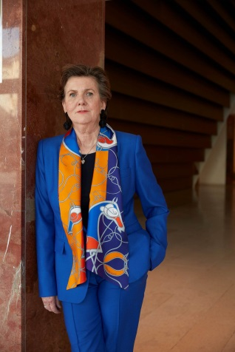

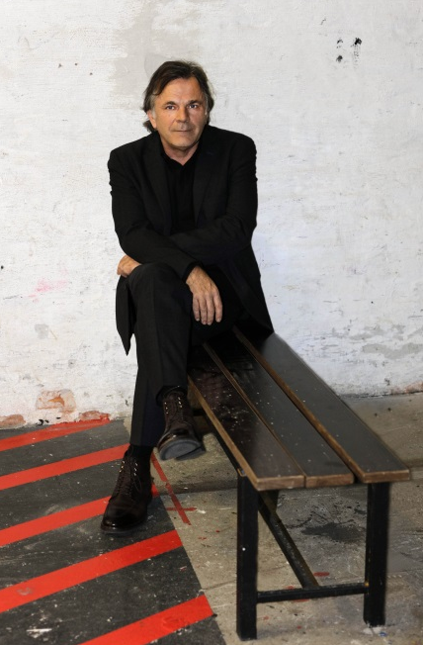

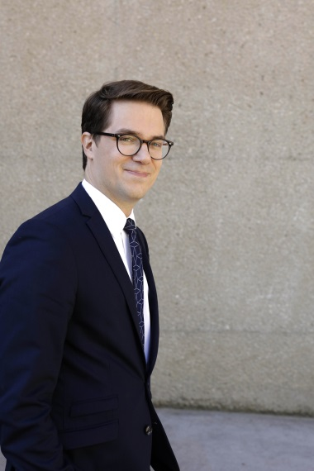

Helga Rabl-Stadler
Festival President
© SF / Lydia Gorges
Lukas Crepaz
Executive Director
© SF / Lydia Gorges
Markus Hinterhäuser
Artistic Director
© SF / Lydia Gorges

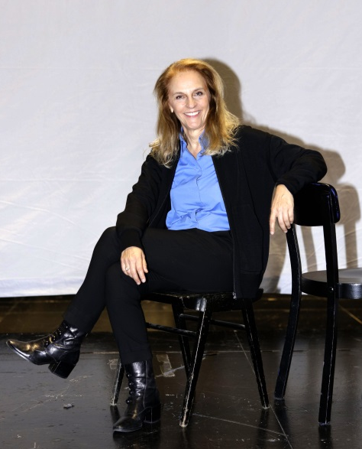

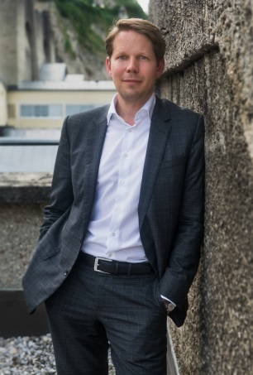

Bettina Hering
Director of Drama
© SF / Lydia Gorges
Florian Wiegand
Director of Concerts and Media
© SF / Marco Borrelli

A Selection of Images of 2019 Festival Artists.
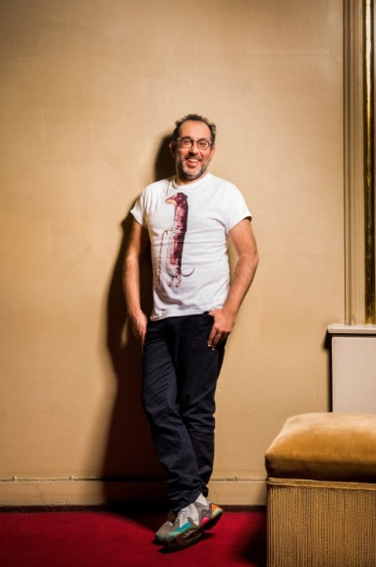
Further photographs may be found in the Photo Service on our website.
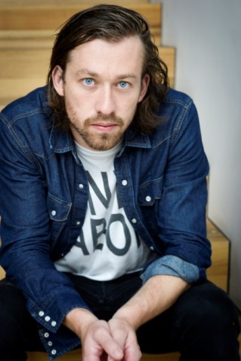
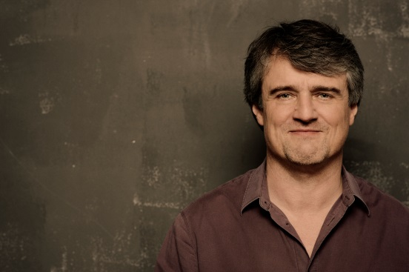
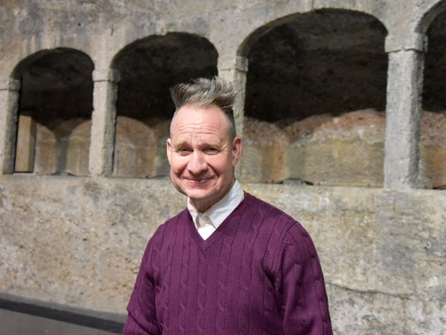
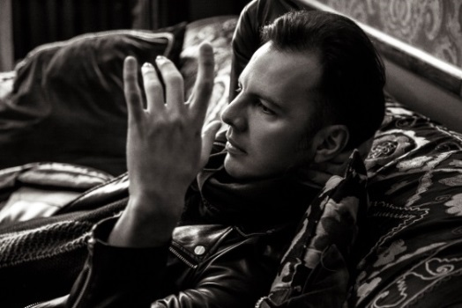
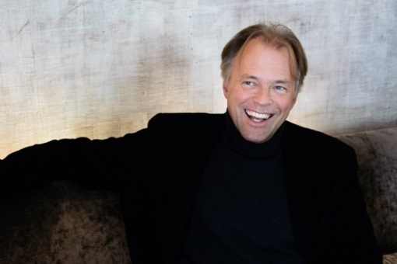
Ingo Metzmacher

© Harald Hoffmann
Peter Sellars

© Anne Zeuner
Teodor Currentzis

© Olya Runyova
Thomas Hengelbrock

© Florence Grandidier

Barrie Kosky

© Jan Windszus

Simon Stone

© Sandra Then
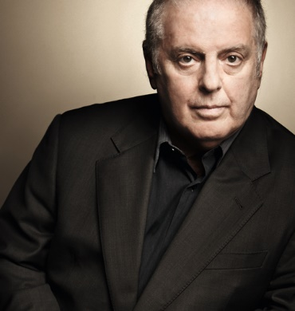
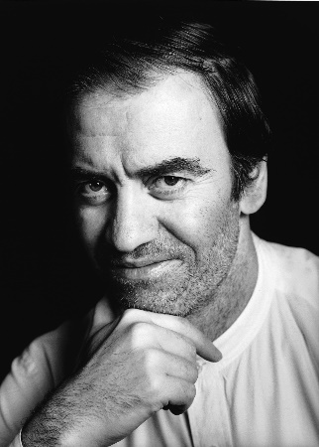

Daniel Barenboim

© Peter Adamik
Valery Gergiev

© Decca / Sasha Gusov

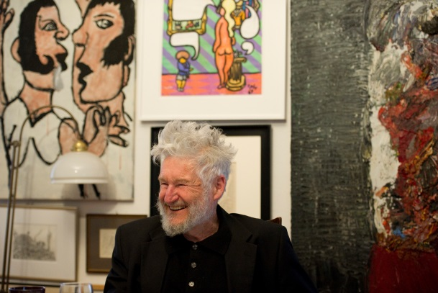
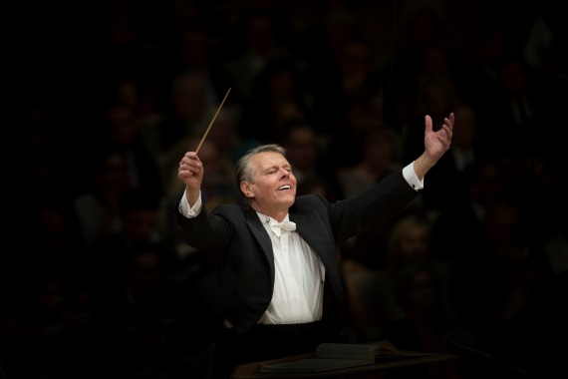

Mariss Jansons

© Peter Meisel (BR)
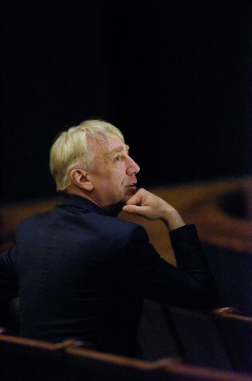
Achim Freyer

© Monika Rittershaus

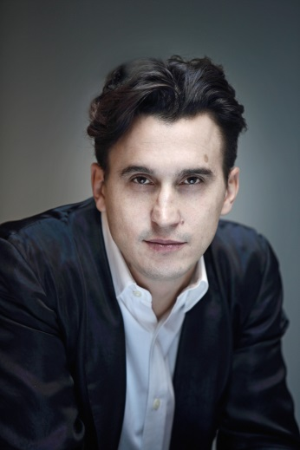
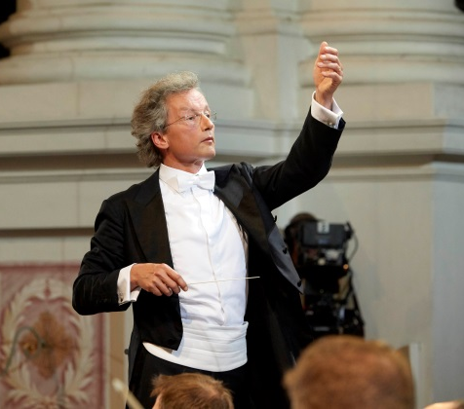

Franz Welser-Möst

© Michael Pöhn
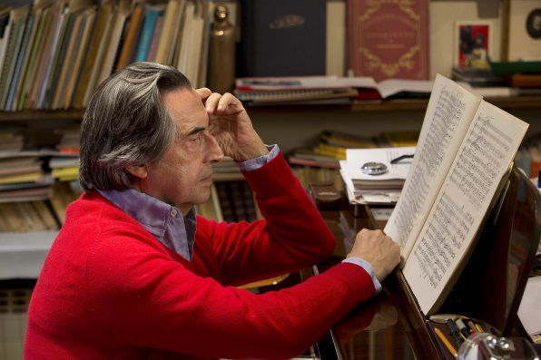
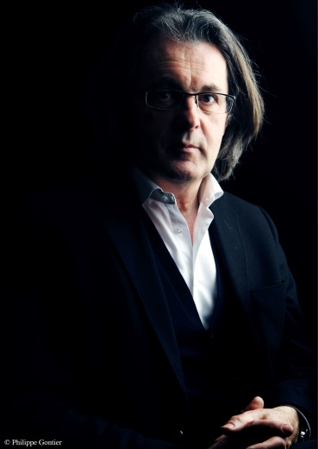
Andreas Kriegenburg

© SF / Thomas Aurin
Damiano Michieletto

© Fabio Lovino

Pascal Dusapin

© Philippe Gontier
Riccardo Muti

© Silvia Lelli / www.riccardomutimusic.com
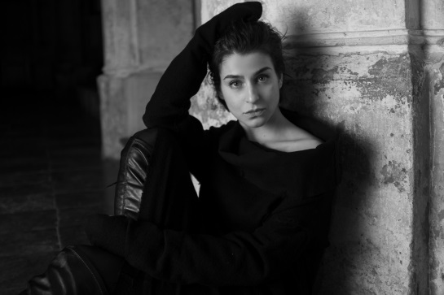
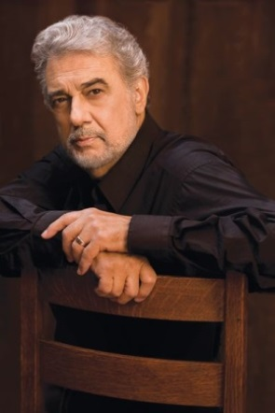
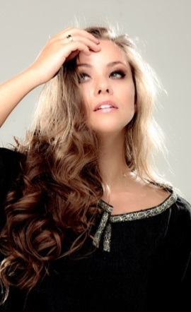

Plácido Domingo

© Greg Gorman/LA Opera
Asmik Grigorian

© Rokas Baltakys

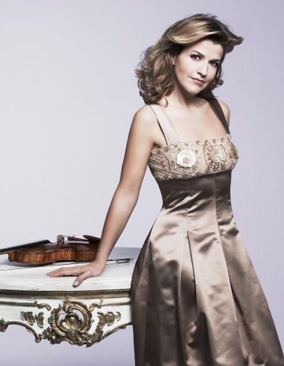
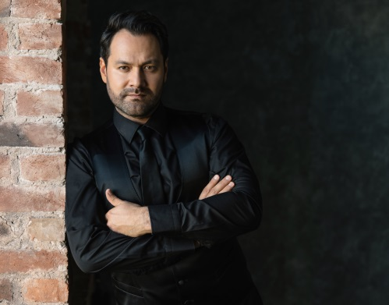

Alisa Kolosova

© Intermusica

Anne Sophie Mutter

© Monika Hoefler
Ildar Abdrazakov

© Sergey Misenko
Sonya Yoncheva

© Victor Santiago
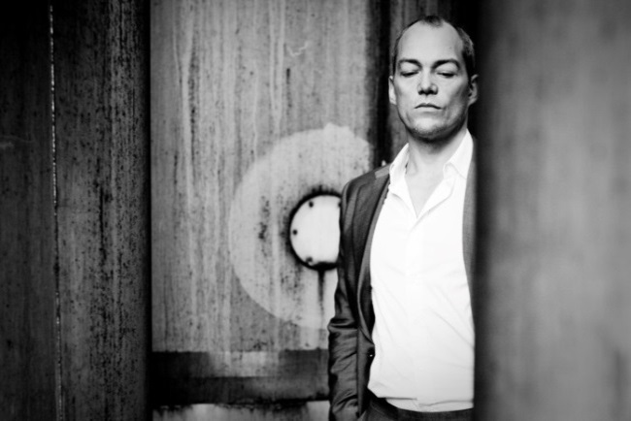
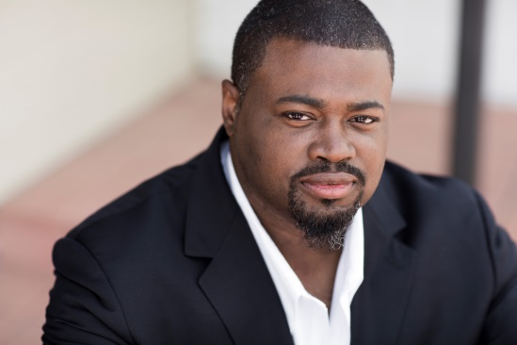

Russell Thomas

© Fay Fox
Christopher Maltman

© Pia Clodi

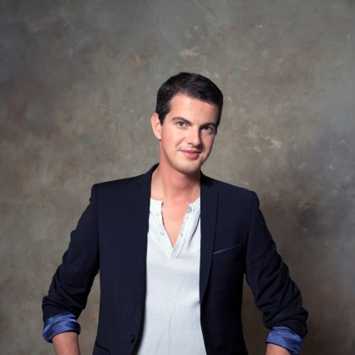
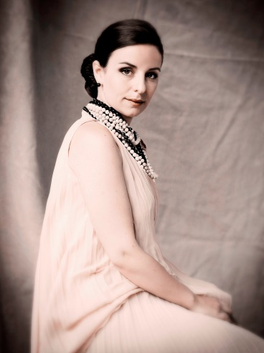
Anaïk Morel

© Ruth Kappus
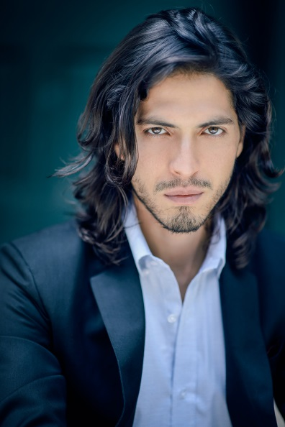

Philippe Jaroussky

© Marc Ribes
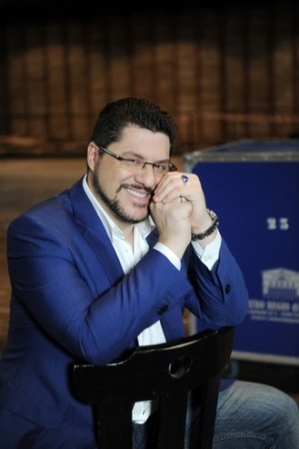
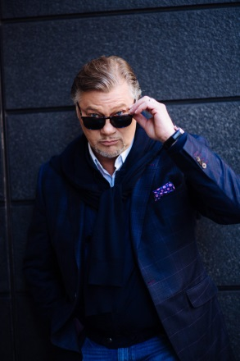
Joel Prieto

© Simon Pauly

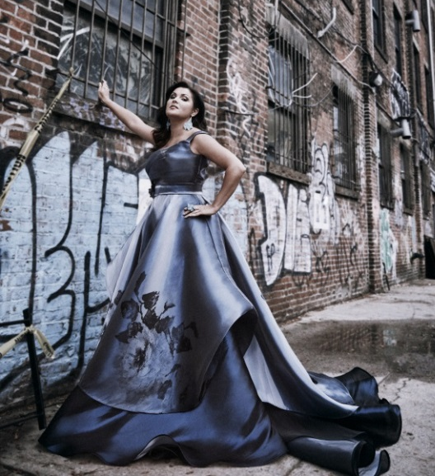

René Pape

© Jiyang Chen
Luca Salsi

© Fabrizio de Blasio
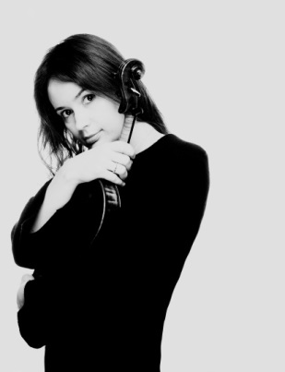
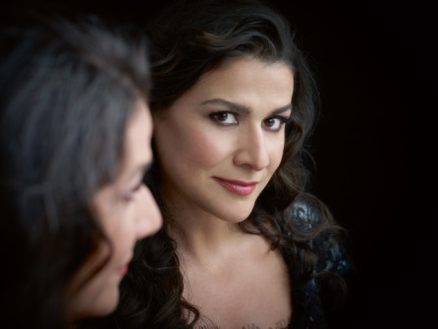

Anna Netrebko

© Kirk Edwards

Patricia Kopatchinskaja

© Marco Borggreve
Cecilia Bartoli

© Decca/Uli Weber
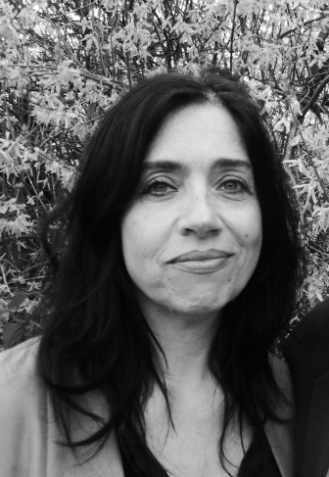
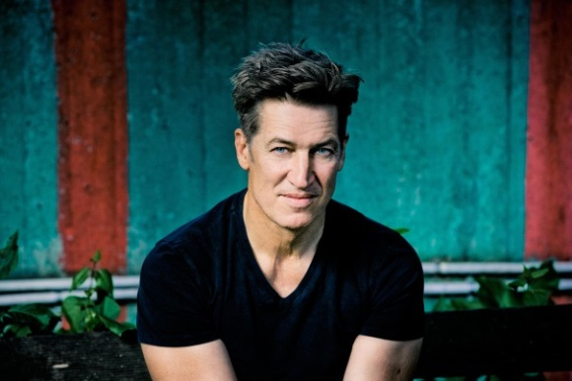
Tobias Moretti

© Christian Hartmann

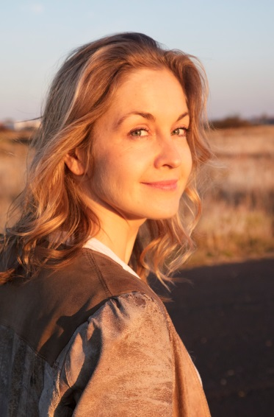
Theresia Walser

© Susanne Jeffs
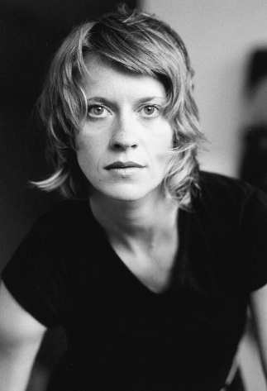
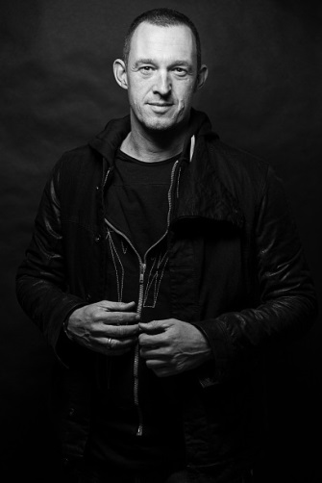

Caroline Peters

© Georg Soulek
Valery Tscheplanowa

© Just Loomis
Albert Ostermaier

© Kunstverlust e.V.
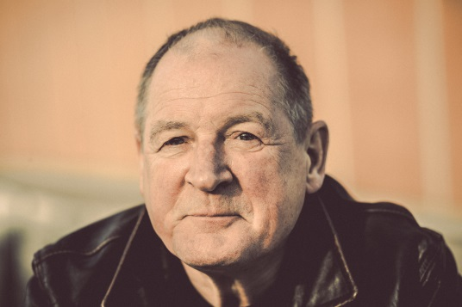
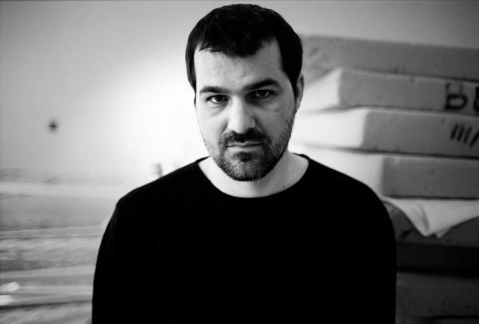

Burghart Klaußner

© Max Parovsky
Kornél Mundruczó

© Decca / Uli Weber
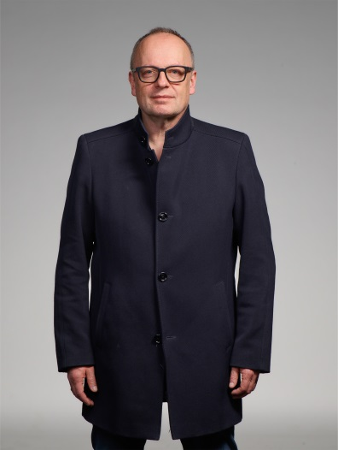
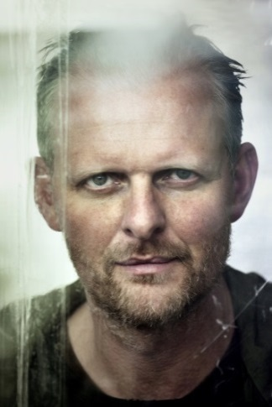
Thomas Ostermeier

© Paolo Pellegrin
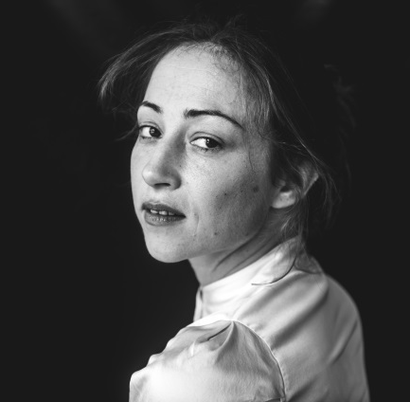

Aenne Schwarz

© Michela Di Savino
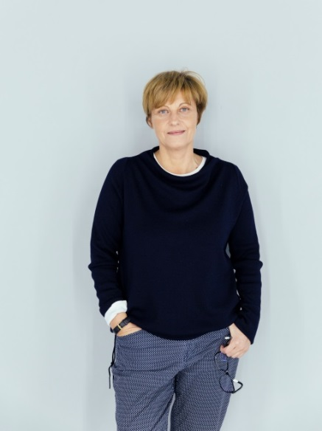
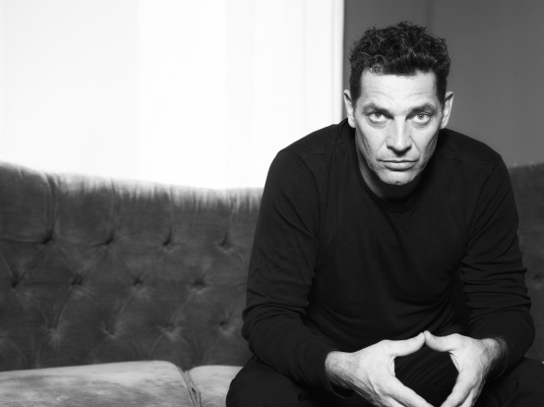
Burkhard C. Kosminski

© Maks Richter

Gregor Bloéb

© Guenther Egger
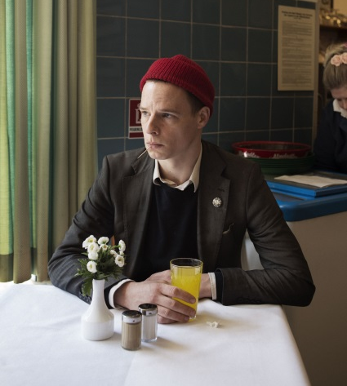
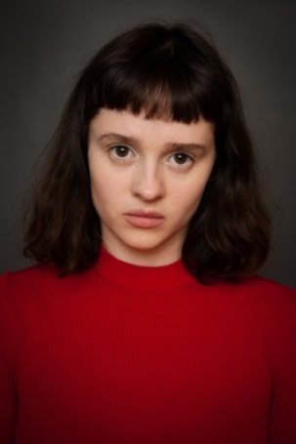
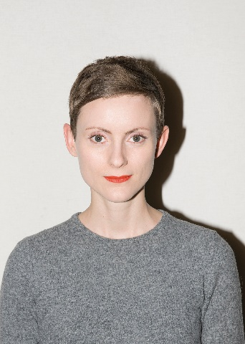
Jörg Pohl

© Armin Smailovic
Mateja Koleznik

© Thomas Dashuber

Veronika Bachfischer

© Franziska Sinn
Maresi Riegner

© Christoph Liebentritt

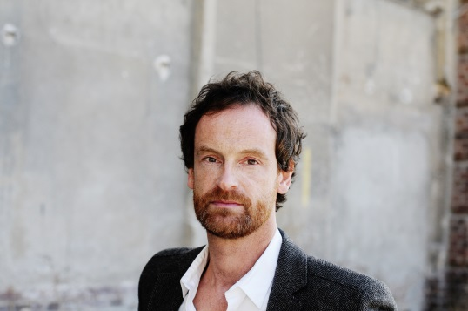
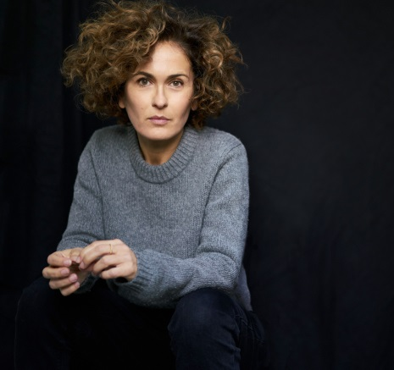
Marie-Lou Sellem

© Axl Jansen

Jörg Hartmann

© Stefan Klueter
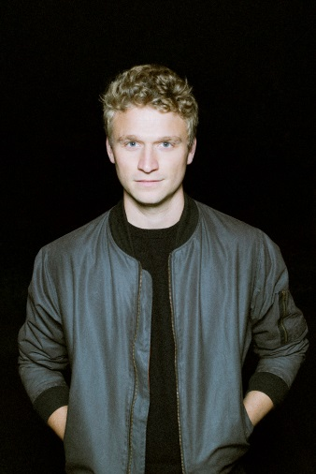

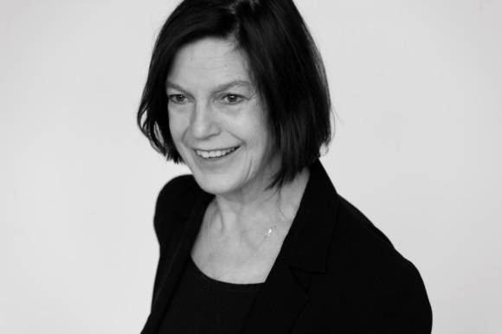
Angela Winkler

© Ruth Walz

Laurenz Laufenberg

© Phillip Zwanzig

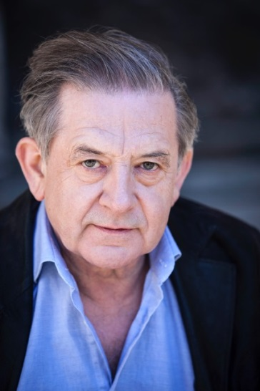
André Jung

© Steffi Henn
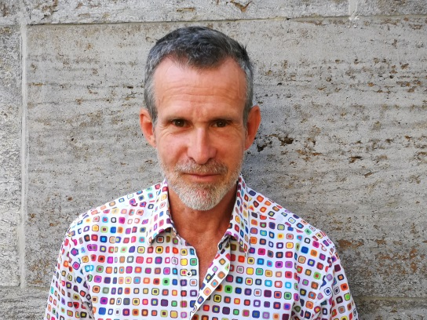
Ulrich Matthes

© Privat

